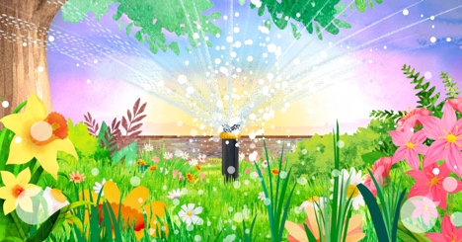

Activities for “Garden Party Time”

1. Vocabulary Activities
Word Hunt:
- Find and list words about nature and the party from the song:
  - Animals: butterflies, hummingbirds, bees, bugs, birds.
  - Plants & natural elements: garden, flowers, trees, fruits, nectar, buds, blooms.
  - Actions: flutter, dance, glide, buzz, pollinate, collect, shine, grow.
Sorting Game:
- Put words into categories:
  - Nouns: garden, party, nectar, buds, sun.
  - Verbs: flutter, shine, collect, grow.
  - Adjectives: juicy, bright, tiny, fresh, sweet, yummy, colored.
Synonyms / Antonyms:
- Synonyms: yummy → tasty, shine → glow, fresh → new.
- Antonyms: light ↔ dark, open ↔ closed.
Rhyme Fun:
- Identify rhymes in the song (wide–glide, near–appear, bite–appetite, share–air).
- Make new rhymes with song words (bee–tree, flower–shower).

2. Content Activities
Reading Comprehension:
- Which animals appear in the garden?
- Why are bees important in the garden party?
- What natural elements (fruits, flowers, trees) are described?
Sequencing:
- Cut or print parts of the song. Ask children to place them in the correct order.
Think and Discuss:
- Why does the garden feel like a party?
- What makes the garden magical in the song?
- What would happen if there were no bees or butterflies?

3. Grammar Activities
Verb Tenses:
- Spot verbs in the present (buzzing, pollinating, dancing).
- Change them into the past (Yesterday the butterflies fluttered in the garden).
- Change them into the future (Tomorrow the bees will collect nectar).
Nouns + Adjectives:
- Underline combinations like brightly colored butterflies, juicy fruits, tiny buds.
- Invent new pairs: happy bees, glowing flowers, fresh fruits.
Questions Practice:
- Write invitation questions:
  - Would you like to join the garden party?
  - What flowers do you see?

4. Literary Activities
Figures of Speech:
- Personification: The trees reach out to greet (Can trees really greet?).
- Metaphor: Nature’s wonders in disguise (What does that mean?).
New Verse Creation:
- Ask kids to invent a new stanza with another animal or plant (e.g., ladybugs, snails, or rainbows).

Comparison:
- Read another short poem about nature and compare its images with Garden Party Time.

5. Creative Activities
Arts & Crafts:
- Draw the garden scene with butterflies, hummingbirds, bees, and fruits.
- Make paper flowers or butterflies and decorate a mural.
Music & Drama:
- Act out the animals: flutter like butterflies, buzz like bees, glide like hummingbirds.
- Create a short dance with garden-inspired movements.
Creative Writing:
- Imagine if it rained during the party—what would happen? Write a short story.
- Write a message about why it is important to protect gardens and flowers.

